|  |  |
| --- | --- |
| 翻译前字数 | 502 |
| 翻译后字数 | 1322 |
| 目录 | Unity Manual/Animation/Animator Controllers/Animator Override Controllers |
| 链接 | <https://docs.unity3d.com/540/Documentation/Manual/AnimatorOverrideController.html> |

**Animator Override Controllers**

**Animator Override Controllers**

The Animator Override Controller is a type of asset which allows you to extend an existing Animator Controller, replacing the specific animations used but otherwise retaining the original’s structure, parameters and logic.

Animator Override Controller是已存在的动画控制器的扩展资源类型，替换所使用的特定动画，但保留原始结构，参数和逻辑。

This allows you to create multiple variants of the same basic state machine, but with each using different sets of animations. For example, your game may have a variety of NPC types living in the world, but each type (goblin, ogre, elf, etc) has their own unique animations for walking, idling, sitting, etc.

允许您创建基本状态相同的状态机变体，但每个变体使用不同的动画集。举个例子，您的游戏在世界里可能有各种各样的NPC，但每种类型（地精，食人魔，精灵等）的行走，空闲，坐着等等都有自己独特的动画。

By creating one “base” Animator Controller containing the logic for all NPC types, you could then create an override for each type and drop in their respective animation files.

为所有NPC类型创建一个包含逻辑的基本的动画控制器，您可以为每种类型创建Animator Override Controllers，并放置各自的动画文件。

To demonstrate, here’s a typical Animator Controller asset:

为了演示，这有一个典型的动画控制器资源。

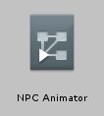

This represents an Animator Controller containing a simple state machine with a blend tree controlling animations in four directions, plus an idle animation, looking like this:

它所表现的动画控制器包含一个简单的状态机，它带有控制四个方向，加一个静止动画的混合树，看起来像这样：

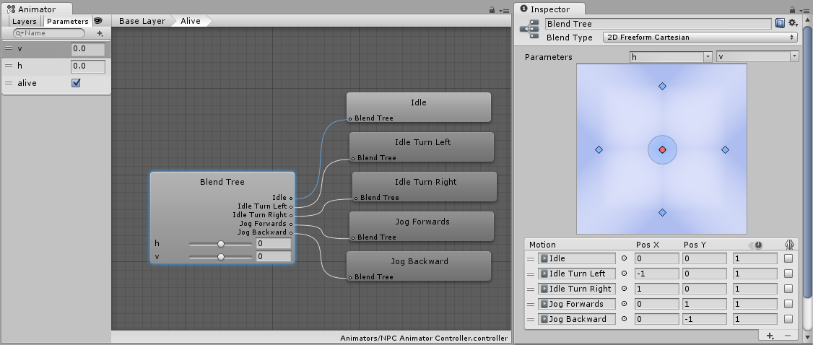

To extend this general NPC state machine to use unique animations which just apply to - say - an ogre-type character, you can create an Animator Override Controller and drop in the Ogre’s animation clips as replacements to the original animation clips. The Ogre may have a different way of idling and moving around, perhaps with slower, heavier and more muscular motion. However, using an Animator Override Controller, the basic logic for how to transistion and blend between movement states can be shared between different characters with different sets of animation, reducing the work required building and modifying state machines themselves.

要扩展通用的NPC状态机，以便为怪物类型的角色应用独特的动画，您可以创建Animator Override Controller，并将动画剪辑放入其中，代替原始的动画。

您可以创建一个Animator Override Controller，并且放置怪物的动画剪辑替换原始的动画剪辑。怪物可能有不同的空闲或者闲逛的动画，或许带有缓慢，沉重或者显得更加强壮的运动。然而。使用Animator Override Controller，在运动状态之间的转换与混合的基本逻辑，可以在具有不同的动画集合的不同角色之间共享，减少了创建和修改状态机本身所需的工作。

To create a new Animator Override Controller, use the **Assets -> Create** menu, or the **Create button** in the Project view, and select Animator Override Controller.

创建一个新的Animator Override Controllers，使用**Assets -> Create** 菜单，或者在工程窗口选择 **Create 按钮**，选择Animator Override Controller。

The Animator Override Controller has a very similar icon to the Animator Controller, except that it has a “plus” sign rather than a “play” sign in the corner of the icon:

Animator Override Controller有近似于Animator Controller的图标，除了图标的角有一个加号标识而不是一个播放标识。

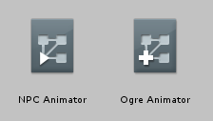Comparing icons: The Animator Controller and the Animator Override Controller assets side-by-side

比较图标：Animator Controller和Animator Override Controller资源并排

When you select the new Animator Override Controller in the inspector, it will initially be unassigned, and will look like this:

当选择了一个新的Animator Override Controller的时的检视面板，它最初未分配，将会如下所示：

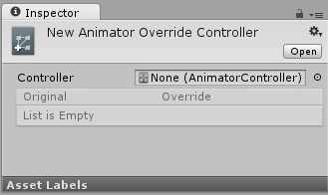An Animator Override Controller with no Animator Controller assigned

一个未指定Animator Controller的Animator Override Controller

To begin using the Override Controller, you need to assign the original controller asset to the new Override Controller in the inspector. Once this is done, all the animations used in the original controller will show up as a list in the inspector of the override controller:

要开始使用Override Controller，您需要在检视面板上指定原始控制器资源到新的Override Controller。一旦完成，所有使用在原控制器里动画将以列表显示在Override Controller的检视面板上。

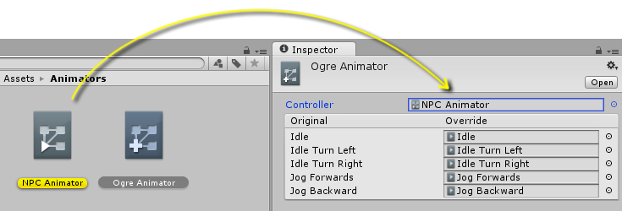Dragging an existing controller into the Animator Override Controller’s inspector

拖拽一个已存在的控制器到Animator Override Controller的检视面板上

You can then assign new animation clips to override the original’s clips. In this example, all the clips have been overridden with the “Ogre” versions of the animation.

您可以指定新的动画剪辑覆盖原始的动画剪辑。在这个例子中，所有剪辑都被怪物版本的动画所覆盖。

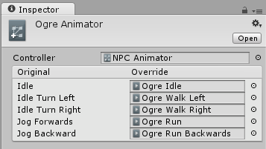The Override Controller with new clips assigned

Override Controller带有指定的新的动画剪辑

This Override Controller can now be used in an animator component on the Ogre character’s Game Object just as if it was an Animator Controller. It will use the same logic as the original Animator Controller, but play the new animations assigned instead of the originals.

这个Override Controller现在可以在怪物的动画组件中使用，就把它当做Animator Controller，但会播放代替原始动画的新动画。

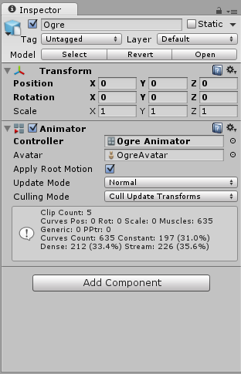The Override Controller in use on a Game Object, in the Animator Component

Override Controller在游戏物体的动画组件上使用